Practicum Final Exam –Even Semester Year 2020/2021
Subject |  |  | COMP6048 - Data Structures |  |  | 
Class | : | B201 / B301 / BC07 / BD07 / BE07 / BF07 / BG01 / BH01 / BK01 / BL01 |  | Start Date | : 17 June 2021
Lecturer | : | D4459 - Gredion Prajena, S. Kom., M.T.I.  D5318 - Jeklin Harefa, S.Kom., M.TI.  D5550 - Fanny, S. Kom., M.TI  D5790 - Muhammad Taufiq Zulfikar, S.Kom., S.Si., M.T.I.  D6434 - Lie Maximilianus Maria Kolbe, S.Kom, M.T.I. |  | Start Time | : 13:20
Lecturer | : |  |  | End Date | : 17 June 2021
Lecturer | : |  |  | End Time | : 15:20

PERATURAN UJIAN:
Exam Regulations:
- Mahasiswa tidak diperbolehkan berdiskusi dan/atau bekerja sama dengan peserta ujian lainnya
Student is not allowed to discuss and/or work together with other exam participants
- Mahasiswa tidak diperbolehkan untuk membuka dan menyalin dari BUKU atau CATATAN, VIDEO dari pengajar (recording kelas, VBL, Youtube, dsb) dan REFERENSI lainnya
Student isn't allowed to open and copy from any resources such as notes, videos (class recording, VBL, Youtube, etc) and other references
- Mahasiswa tidak diperbolehkan membuka dan menyalin jawaban dari internet (google, stackoverflow, dsb)
Student isn't allowed to open and copy answer from the internet (google, stackoverflow, etc)
- Asisten BERHAK memberi nilai 0 (NOL) bagi peserta ujian yang melakukan segala bentuk kecurangan
Assistant is able to give 0 (ZERO) score for exam participant who does any cheating actions
- Kumpulkan jawaban tepat pada waktunya, apabila terlambat mengumpulkan maka jawaban tidak akan dikoreksi dan nilai mahasiswa adalah 0
Submit the answer on time, if not, then the answer will not be checked, and the students will receive 0 (ZERO)
- Bila Anda tidak membaca peraturan ini, maka Anda dianggap telah membaca dan menyetujuinya
If you have missed to read these regulations, so you are considered to have read and agreed on it



SOFTWARE YANG DIGUNAKAN:
Software will be used:
- Dev-C++ 5.11

FILE YANG DIKUMPULKAN:
File must be collected:
- [NIM].CPP

PERHATIAN!
Attention!
- Bagi yang mengerjakan tidak sesuai dengan soal, maka akan diberikan nilai NOL (0)
For those who do not work in accordance with the exam case will be marked as ZERO (0)
- Bagi yang mengerjakan tidak sesuai dengan software dan versi yang telah ditetapkan, maka akan tetap dikoreksi dengan software dan versi yang telah ditetapkan
For those who do not work in accordance with the software and specific version will be corrected by the predefined software and version
- Kompres semua jawaban yang akan diunggah. Pastikan format pengumpulan nama file dan ekstensi sesuai dengan format berikut: [NIM]-[NAMA].zip
Compress all file that will be uploaded. Make sure the format for collecting file name and extension according to the following format: [NIM]-[NAME].zip

Soal
Case

Wak Audition
Wak Audition is an application used by the admin of Wak Singing Audition to manage the contestant data. This application will be developed using AVL Tree data structure. The descriptions of the program are:
- The program consists of 3 menus:
1. View Contestant
2. Register Contestant
3. Call Contestant
4. Exit
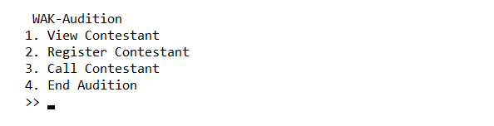
Figure 1. Main Menu
- If user chooses View Contestant (Menu 1):
  - If there is no data in the AVL, print “There is no contestant”
  - Otherwise, ask user to input show method. Validate that the method must be either equals to “Pre”, “In”, or “Post”
Figure 2. Choose Show Method
    - If user chooses “Pre”, show the data using Pre-Order method

Figure 3. View Contestant in Pre-Order
    - If user chooses “In”, show the data using In-Order method

Figure 4. View Contestant in In-Order
    - If user chooses “Post”, show the data using Post-Order method

Figure 5. View Contestant in Post-Order
- If user chooses Insert Contestant (Menu 2):
  - Ask user to input the following data:
    - Contestant Name
      - Validate that the length must be between 6 and 20 characters
      - Validate Contestant name must start with an uppercase letter
      - Validate Contestant name must be at least two words
      - Validate Contestant name must be alphabetical
    - Contestant Gender
      - Validate that the gender must be between “male” or “female” (case sensitive)
    - Song
    - Contestant Age
      - Validate that the age must be between 6 and 59
  - After that, push all the data to AVL Tree with Contestant Name as key
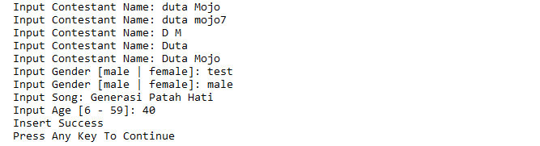
Figure 6. Register Contestant
- If user chooses Call Contestant (Menu 3):
  - If there is no data in the AVL, print “There is no contestant”
  - Otherwise, the program will show all contestants using In-Order method and ask user to input contestant name.
    - Validate contestant name must exist in the AVL Tree
    - Then, ask user to input score for the contestant performance
    - After that, insert contestant data to record the top three contestants based on their score. If there is any contestant who has the same score, the newest one must be on top of the older one
    - Delete the contestant data from the AVL Tree
- If user chooses Exit (Menu 4):
  - Print the data of the top three contestants with the highest score. Add prefix “Mr.” and “Mrs.” for contestant’s name to male and female gender respectively. Then, delete all contestant data in the AVL and close the program.

Please run the EXE file to see the sample program

